Medical Ethics in Addiction Medicine Communications Toolkit

Template Twitter Posts

For a fresh and probing look by @ASAMorg at contemporary medical ethics in addiction medicine, elucidated under @AmerMedicalAssn Principles and Code of Medical Ethics. Learn more: https://tinyurl.com/ethicinsaddictionmedicine

The @ASAMorg public policy statement on Medical Ethics in Addiction Medicine supports addiction specialist physicians confronting tough ethical dilemmas in daily clinical practice, including ethics & drug testing in addiction treatment https://tinyurl.com/ethicinsaddictionmedicine

Medical Ethics in Addiction Medicine offers practical guidance to addiction specialist physicians and can apply to any physician or healthcare professional engaged in addiction treatment. Learn more: https://tinyurl.com/ethicinsaddictionmedicine

It is vital for addiction specialist physicians across settings to acknowledge ethical dilemmas in clinical practice and consider and employ ethical practices when treating patients with addiction. Read the @ASAMorg Public Policy Statement on Medical Ethics in Addiction Medicine now to learn more: https://tinyurl.com/ethicinsaddictionmedicine

Template Facebook Posts

A fresh and probing look at contemporary medical ethics by the [@American Society of Addiction Medicine – ASAM] elucidated under the [@American Medical Association (AMA)] Principles and Code of Medical Ethics, supports addiction specialist physicians and helpful for any physician or healthcare professional engaged in addiction treatment. Learn more: https://tinyurl.com/ethicinsaddictionmedicine

The ASAM public policy statement on Medical Ethics in Addiction Medicine supports addiction specialist physicians confronting tough ethical dilemmas in daily clinical practice, including ethics & drug testing in addiction treatment. https://tinyurl.com/ethicinsaddictionmedicine

It is vital for addiction specialist physicians across settings to acknowledge ethical dilemmas in clinical practice and consider and employ ethical practices when treating patients with addiction. Read the ASAM Public Policy Statement on Medical Ethics in Addiction Medicine now to learn more: https://tinyurl.com/ethicinsaddictionmedicine

Template Social Graphic

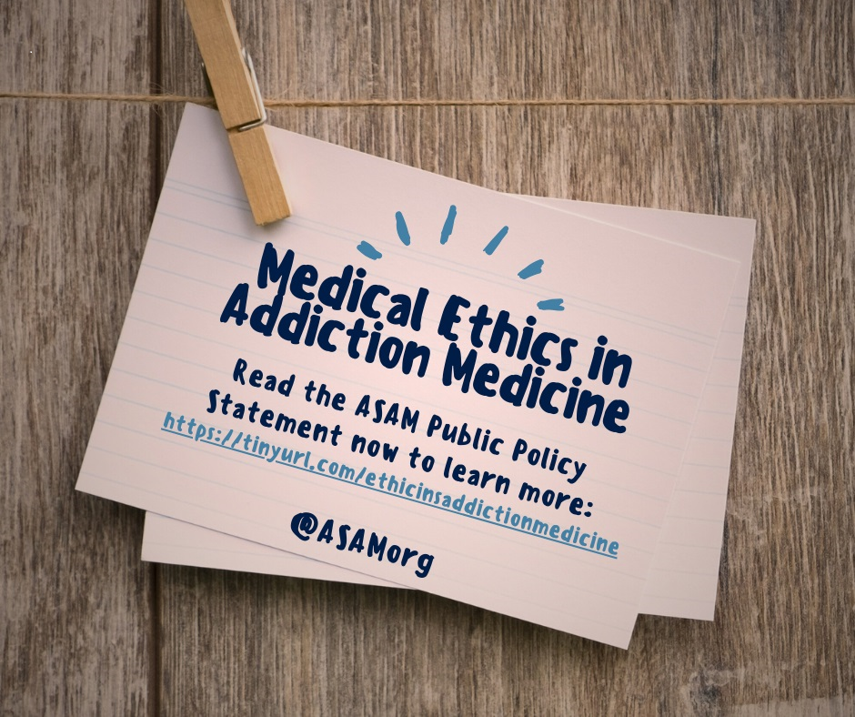

Template Newsletter Content

The American Society of Addiction Medicine (ASAM) has announced the adoption of a policy statement that gives a fresh and probing look at medical ethics in addiction medicine, and supports addiction specialist physicians (ASPs) confronting tough ethical dilemmas in daily clinical practice, including ethics in drug testing in addiction treatment. The Public Policy Statement on Medical Ethics in Addiction Medicine is elucidated under the American Medical Association’s (AMA) Principles and Cope of Medical Ethics and offers practical guidance to addiction specialist physicians to consider when practicing addiction medicine.

